TEAM MCCCXXXVII
Mike Doran, Colin Fischer, Carolyn Andrews, Carlos Lazo

Part | Solution
1a. | 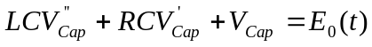
1b. | 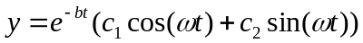 where ω = 10⁷ rad/s and b = 100 ohms/h
1c. | 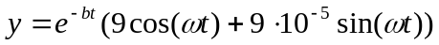where ω = 10⁷ rad/s and b = 100 ohms/h
1d. | 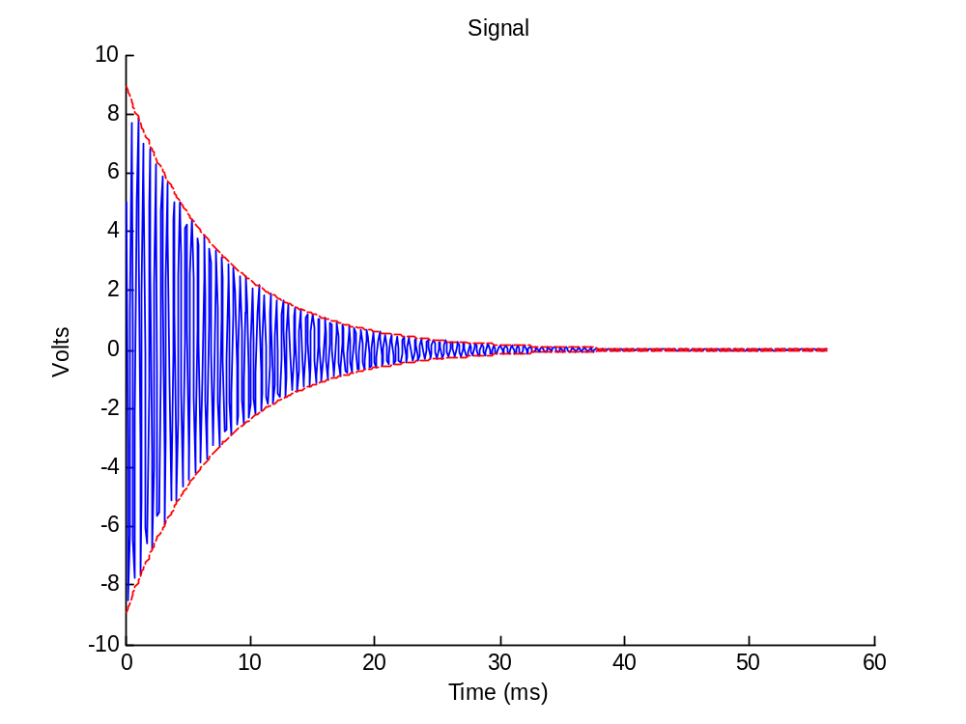
1e. | 1.59MHz

1f. | The characteristic pulse time is 20ms.  This was chosen by implementing approximately a 9dB.  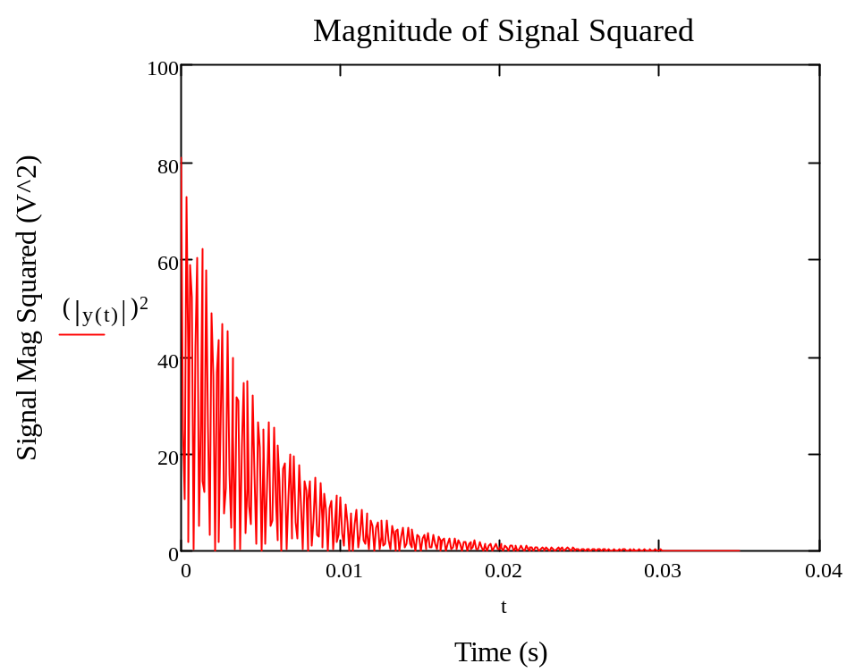  The 9dB drop allows us to capture most of the signal energy by the time 20ms, as seen in the figure above. We determined that the integral of our curve in 20ms versus the 100ms step click area is approximately the same – therefore, we’re treating the signals as being identical.
1g. | Our detector can sense a signal that is 5 times weaker than the original signal. Therefore our detection range radius is times larger that the original radius.
2a. | 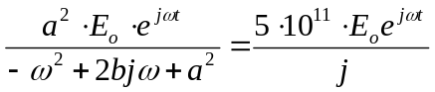 = Steady State Differential Equation  Where: 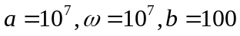
2b. | Gain = 50,000.00 or -93.98dB
2c. | 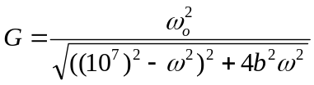  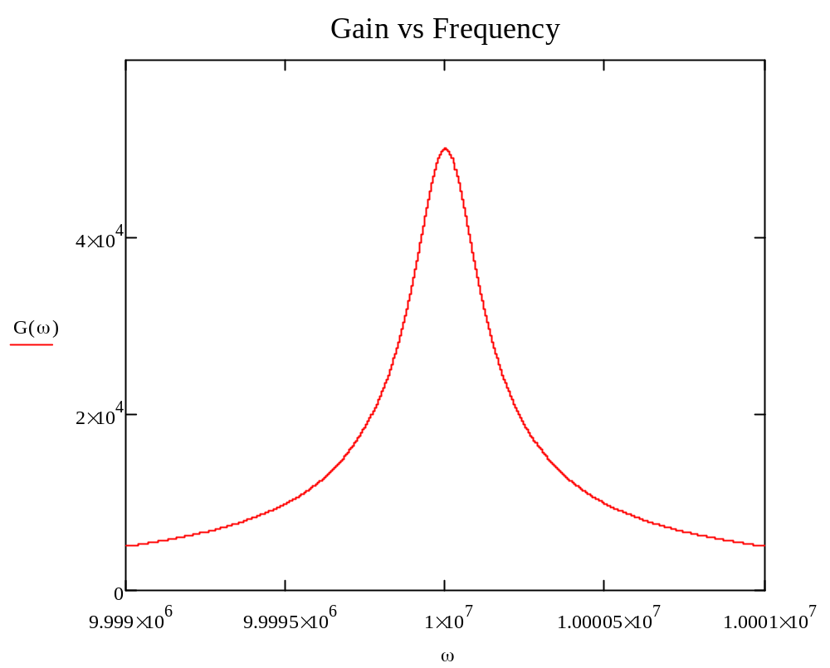
2d. | 346Hz bandwidth. The resonant frequency is 10Mhz

